**Richard Bell  
ECE 271A  
HW 1**

1. We can assume that the ratio of the number of ‘Cheetah’ training samples to the number of ‘Background + Cheetah’ training samples corresponds to that of the true population. This allows us to say that P(Cheetah)= 19% and P(Background) = 1 – P(Cheetah) = 81%.
2. The histograms of the training data are shown below. We use these to compute the conditional probabilities P(x|Cheetah) and P(x|Background), which are needed to calculate our Bayesian classifier: Decide Cheetah if P(x|Cheetah)P(Cheetah) > P(x|Background)P(Background).

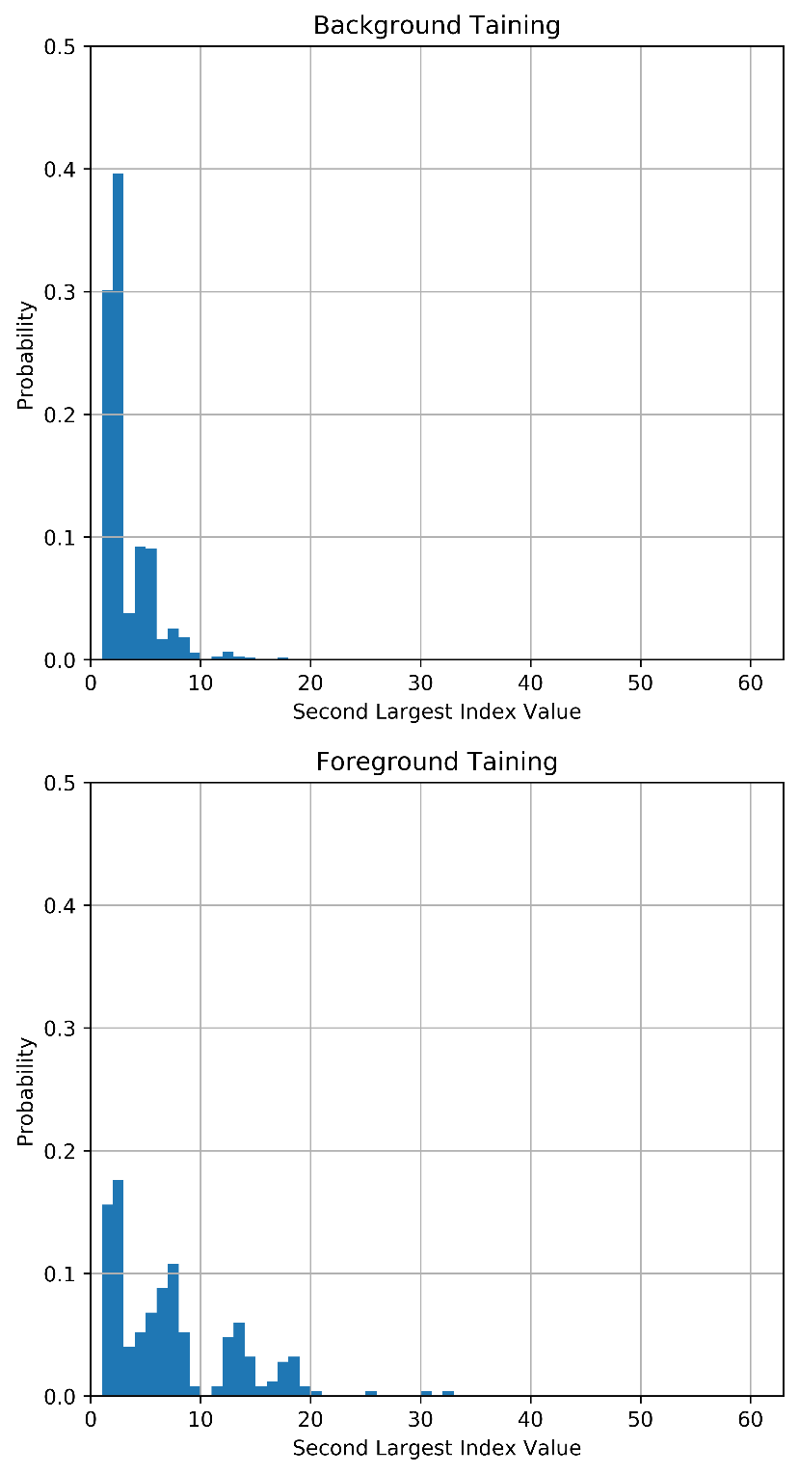

1. My generated Cheetah Mask is shown below. This was the best I could do.  
     
   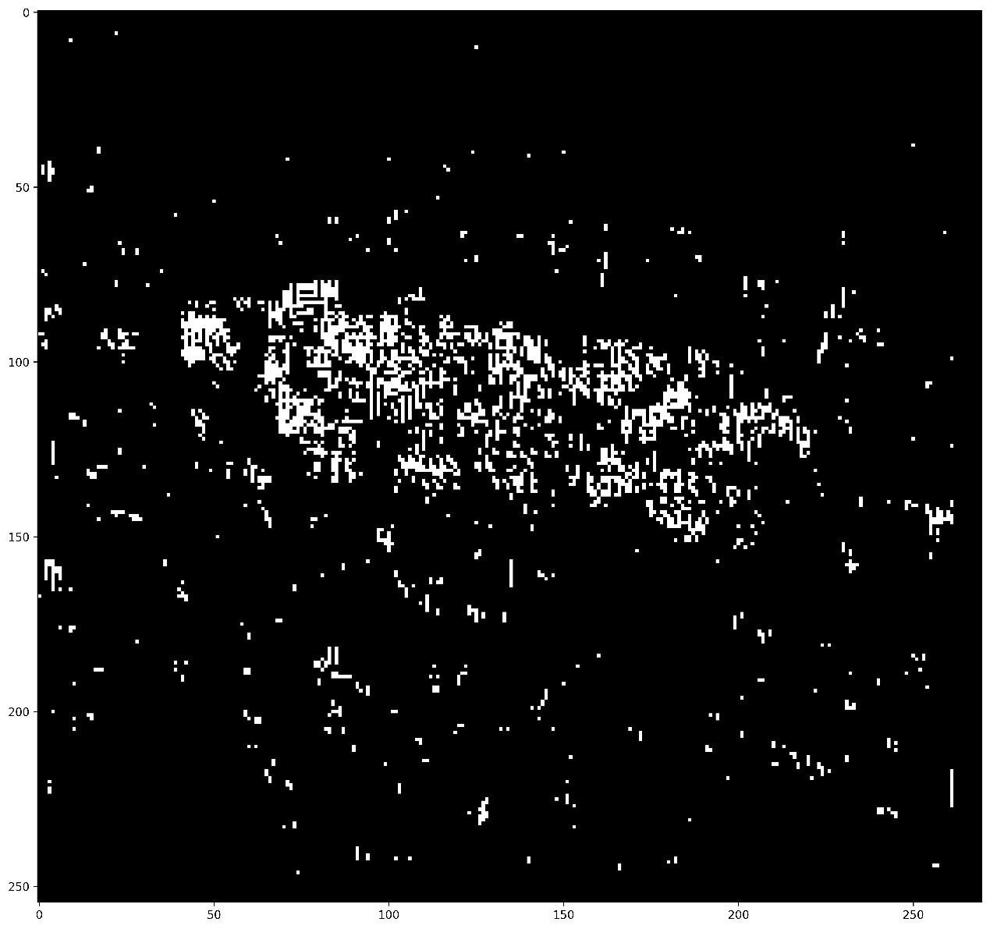
2. The probability of error was computed by comparing the above mask to the true mask pixel by pixel and counting the number of times the pixels did not agree. This produced **P(error) = 16.84%.** I found that the optimal priors to use were P(Cheetah) = 16% and P(Background) = 84%.